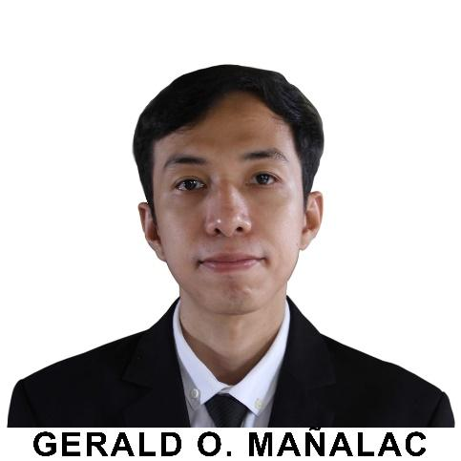

**GERALD O. MAÑALAC**

 432 Zone 6 San Matias, Santa Rita, Pampanga

 geraldolayresmanalac@gmail.com

 +63905-1757-955

**OBJECTIVES:**

To enhance my educational and professional skills in a stable and dynamic workplace and to build a long-term career in the Information Technology industry with opportunities for career growth.

**WORK EXPERIENCE:**

Special Program for Employment of Students (SPES)

Office of the Municipal Assessor

Municipality of Santa Rita

San Jose, Santa Rita, Pampanga

May 2019

**EDUCATIONAL ATTAINMENT:**

Tertiary:

Bachelor of Science in Information Technology

Don Honorio Ventura State University

Bacolor, Pampanga

S.Y. 2018 up to present

Secondary:

Becuran High School

Becuran, Sta. Rita, Pampanga

S.Y. 2003 - 2007

Primary:

San Matias Elementary School

San Matias, Sta. Rita, Pampanga

S.Y. 1997 - 2003

**SEMINAR ATTENDED:**

#SMLSEMINAR Social Media Literacy Seminar

Don Honorio Ventura State University

Multi-Purpose Covered Court

Bacolor, Pampanga

November 22, 2018

**ACHIEVEMENTS**

**President’s Lister:** Don Honorio Ventura State University

1st Semester A.Y. 2020-2021

**President’s Lister:** Don Honorio Ventura State University

1st Semester A.Y. 2019-2020

**Dean’s Lister:** Don Honorio Ventura State University

2nd Semester A.Y. 2018-2019

**President’s Lister:** Don Honorio Ventura State University

1st Semester A.Y. 2018-2019

**PERSONAL INFORMATION:**

| Birthdate | : | October 31, 1990 |
| --- | --- | --- |
| Birthplace | : | Guagua, Pampanga |
| Gender | : | Male |
| Height | : | 5’4 |
| Weight | : | 90 lbs. |
| Civil Status | : | Single |
| Nationality | : | Filipino |
| Religion | : | Roman Catholic |
| Languages | : | English, Tagalog, Pampango |

**CHARACTER REFERENCE:**

**Mrs. Nelda D. Salvador**

Municipal Assessor

Office of the Municipal Assessor

Municipality of Santa Rita

Santa Rita, Pampanga

I declare under oath that this Curriculum Vitae has been accomplished by me, and is a true, correct and complete statement pursuant to the provisions of pertinent laws, rules and regulations of the Republic of the Philippines. I also authorize the agency head / authorized representative to verify / validate the contents stated herein. I trust that this information shall remain confidential.

GERALD O. MAÑALAC

          Applicant